**AI ASSN.- l**

1. Breadth-first and depth-first are two algorithms for performing uninformed search—a search that does not use knowledge about the goal of the search. Implement both search algorithms and test them on following graph (1 is the Start node and 3 is the Goal Node).

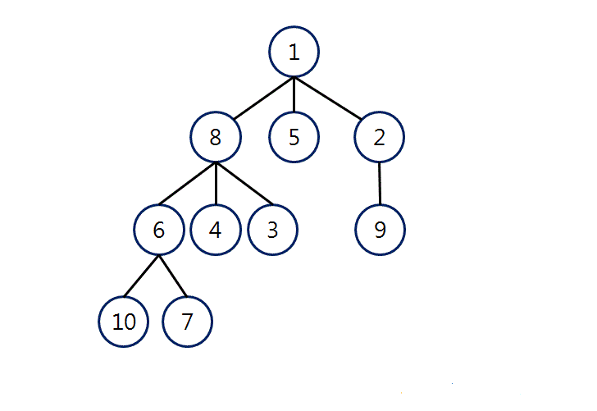

1. Best-first search is a search algorithm which explores a graph by expanding the most promising node chosen according to a specified rule. You need to implement greedy version of this search algorithm and test them on following graph (A is the start node and G is the Goal node) and print the Search sequence.

